**Packet Sniffing and Spoofing Lab Report**

Submission by- Surya Damerla (Suma)

**Lab Task Set 1: Using Tools to Sniff and Spoof Packets**

**Task 1.1.: Sniffing Packets**

**1.1 A.** Below screenshot shows sniffer.py program used for this task

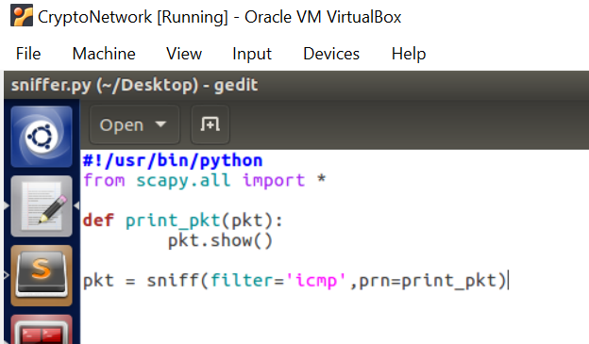

**Figure 1**

Below screenshot shows the ICMP packets captured and printed on the console when I ran the program sniffer.py with root privileges.

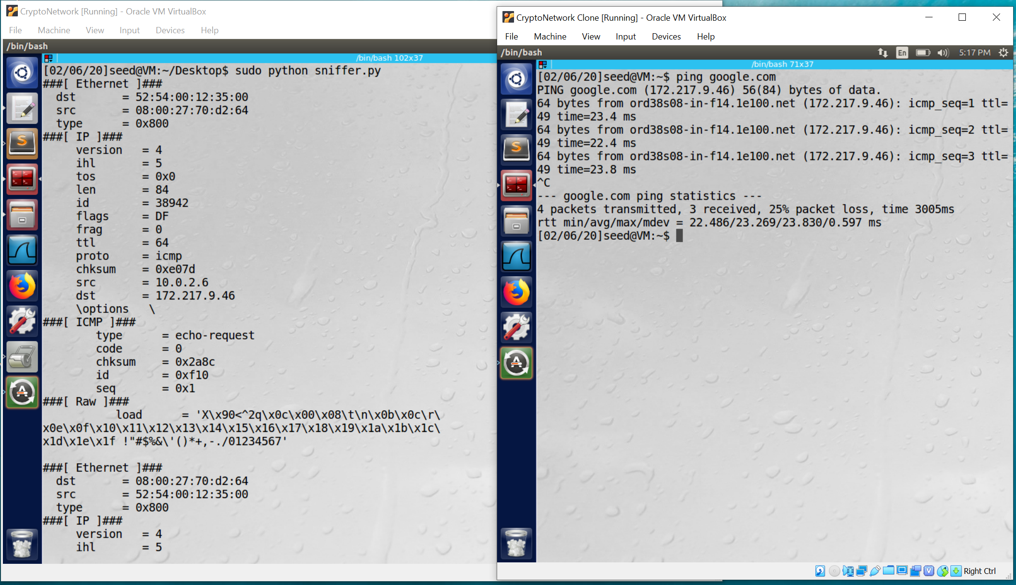

**Figure 2**

Belowscreenshot is when I tried to run the program sniffer.py without any privileges and since the file has only read/write privileges and no executable privilege, it prints an error on the screen

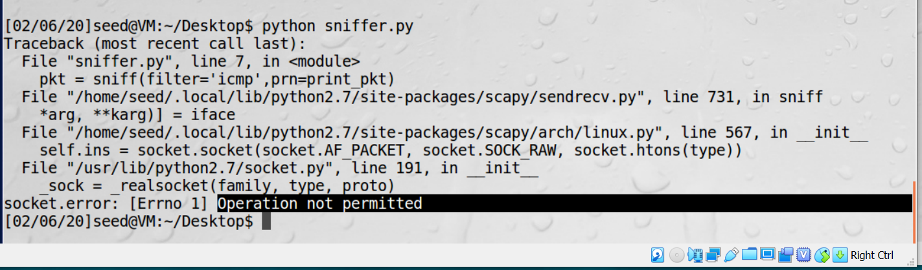

**Figure 3**

**Task 1.1 B  
A. a. Capture only the ICMP packet**

Below screenshot shows the ICMP packet captured using the filter.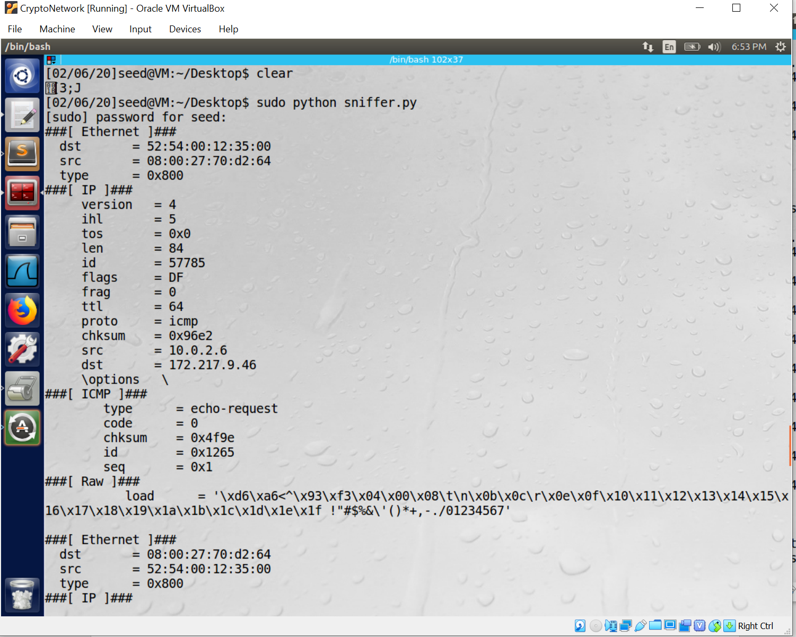

**Figure 4**

Below screenshot shows the code used:

**Figure 5**

**b. Capture any TCP packet that comes from a particular IP and with a destination port number 23.**

**A.**

Below screenshot is the code used: TCP filter is used for port 23.

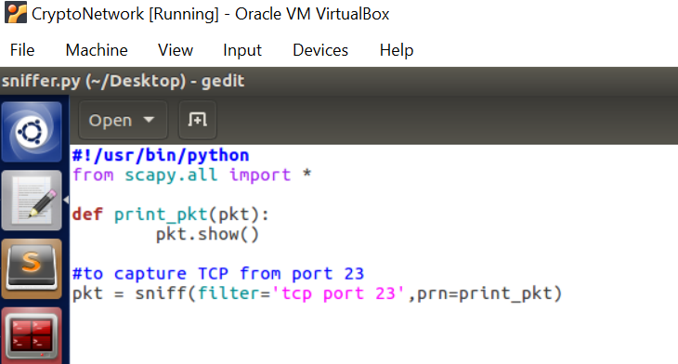

**Figure 6**

Below screenshot shows the TCP packet captured when I tried to connect to google.com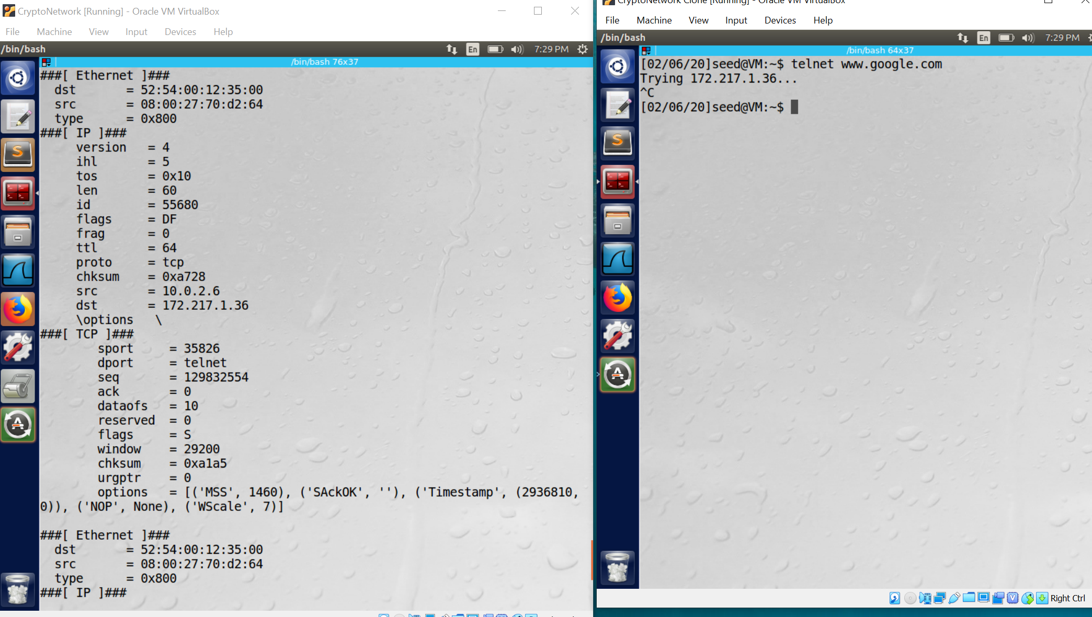

**Figure 7**

**c. Capture packets comes from or to go to a particular subnet. You can pick any subnet, such as 128.230.0.0/16; you should not pick the subnet that your VM is attached to**

**A.** Im trying to filter the packets coming to “10.16.20.0” on port 24 using the below filter command.

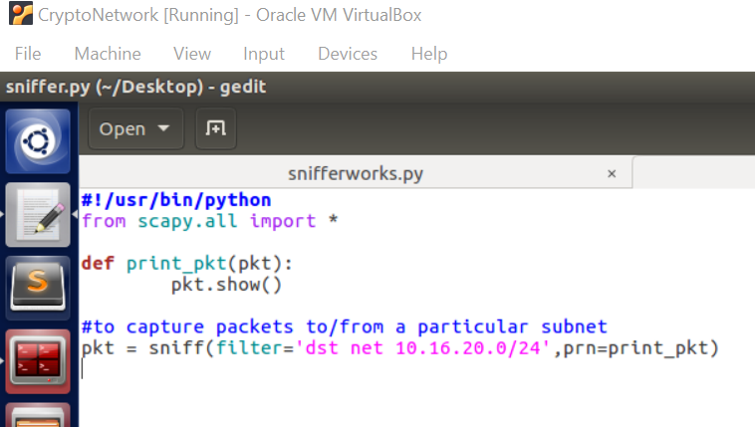 **Figure 8**

Below screenshot shows the captured packet that was sent to the destination “10.16.20.0”

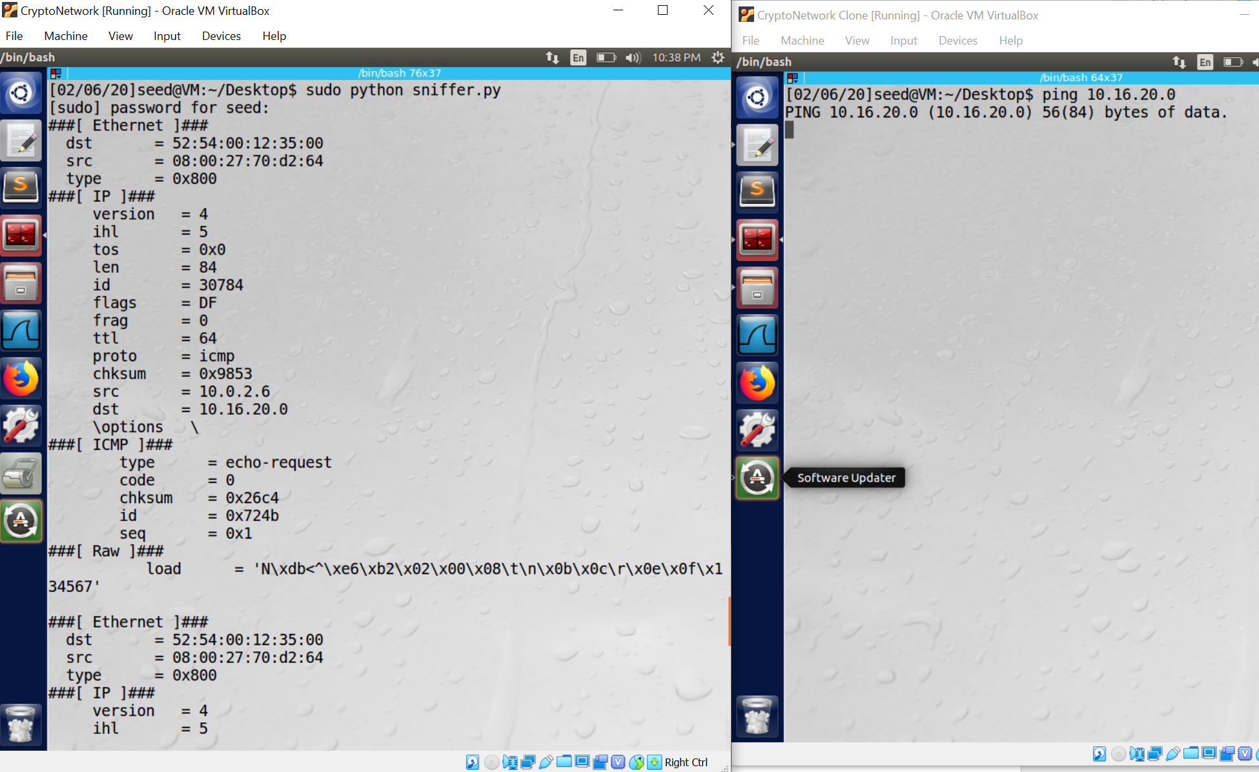

**Figure 9**

**Task 1.2.: Spoofing ICMP Packets**

**A.** Below screenshot is the code snippet used for spoofing ICMP packets. I changed the src= “1.2.3.4” which is not the IP of the current network and dst= “10.0.2.6”. Created a ICMP packet and sent it.

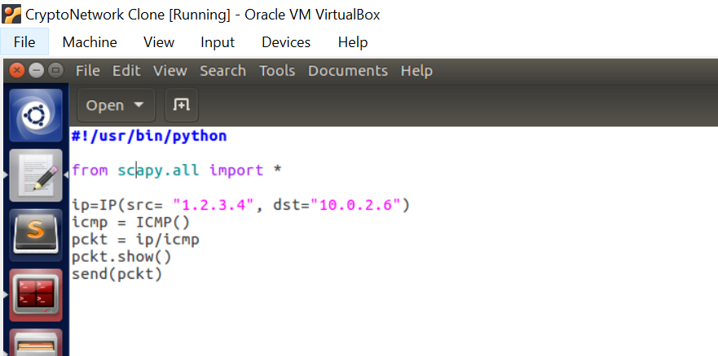

**Figure 10**

Below screenshot shows the captured ICMP packet in Wireshark from source IP=1.2.3.4

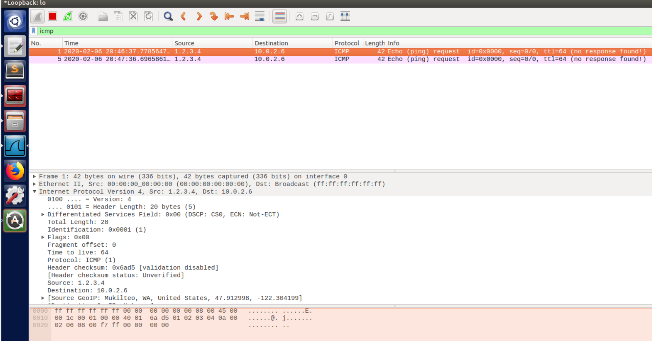

**Figure 10**

**Task 1.3.: Traceroute**

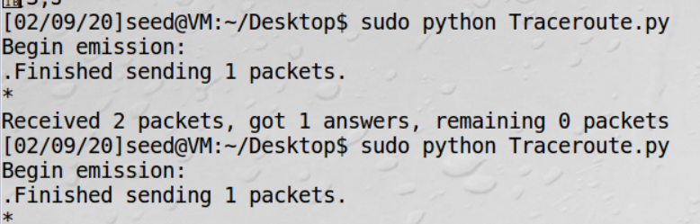

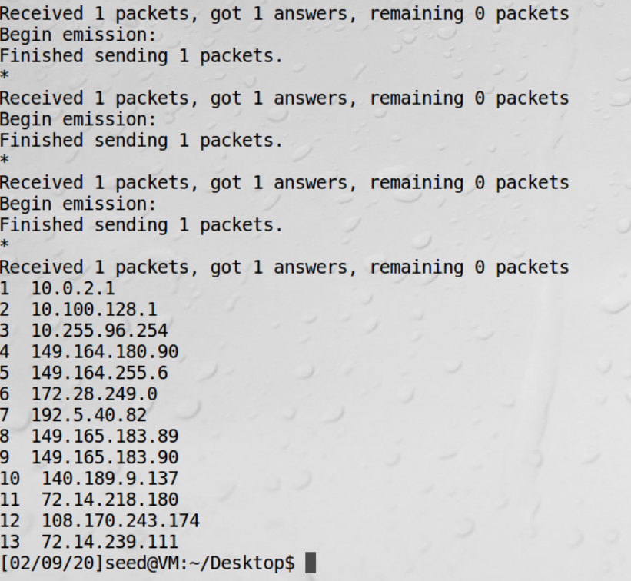

**Figure 11**

**Observation:** The IP address of each router the packet visits are printed in the terminal (as shown in figure 11)

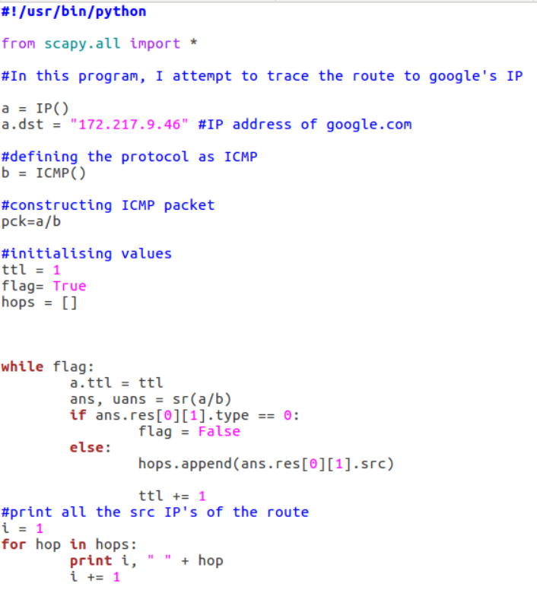

**Figure 12**

**Explanation:** For finding the traceroute, I’m using Scapy function “sr” which is for sending packets and receiving answers. The function returns a couple of packet and answers, and the unanswered packets.

The IP address of each router it hops can be found using “ans.res[0][1].src” as seen in the code.

**Task 1.4.: Sniffing and then Spoofing**

**Ans.** In the below code, I’m filtering the ICMP packets (sniffing) and then in my callback function “print_pkt”, I’m modifying the source IP address and destination IP address of the captured packet and constructing a reply packet (type=0) to be sent. (spoofing)

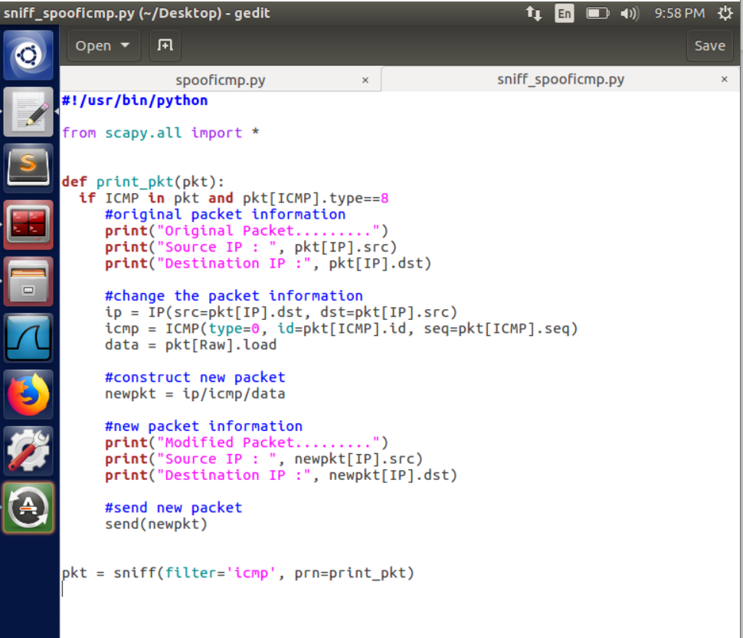

**Figure 13**

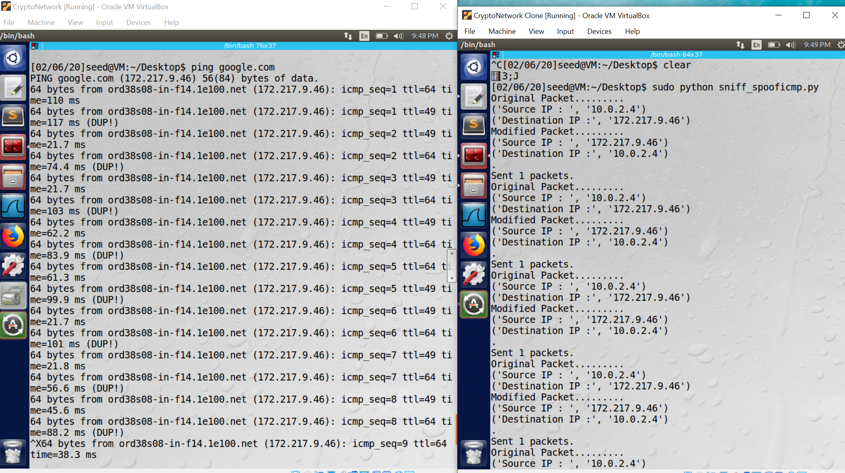

**Figure 14**

Above screenshot (figure 14) shows two VM’s:

* I pinged google.com in one VM which sends out ICMP echo request packets.
* In another VM, I ran the “sniff_spooficmp” program shown in above screenshot. The received packet and the modified packets are printed on the terminal

**Lab Task Set 2: Writing Programs to Sniff and Spoof Packets**

**Task 2.1.: Writing Packet Sniffing Program**

**Task 2.1A: Understanding How a Sniffer Works**

**A.** Below screenshot is the implementation of the sniffer program:

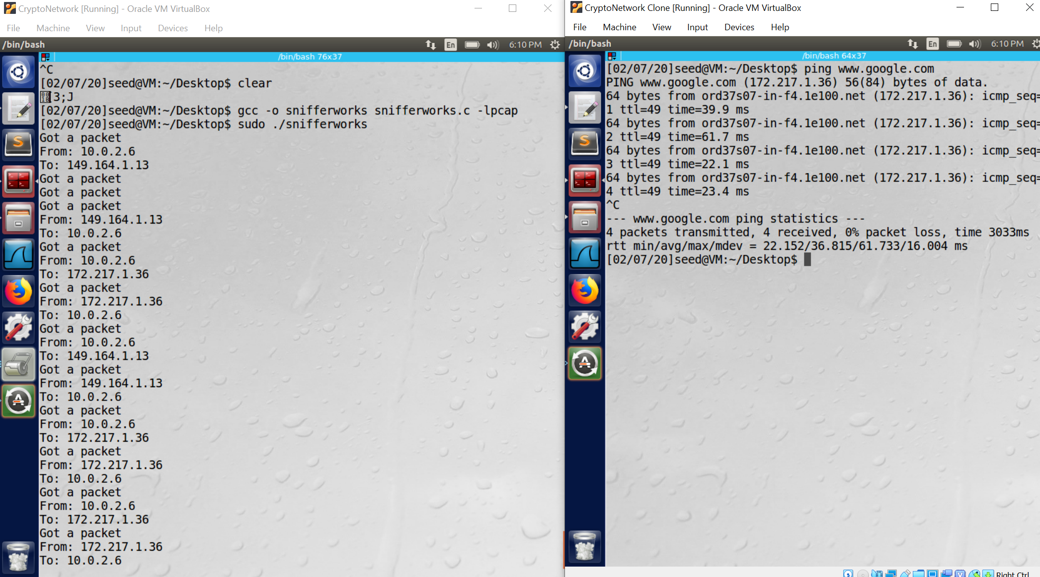

**Figure 15**

**Observation:** In the above screenshot( figure 15), there are two VM’s ,

* + The VM on the right(10.0.2.6) is pinging “google.com”
  + The VM on the left (10.0.2.4) is running the sniffer program and it is able to sniff the packets which are supposed to go to google and not intended for this machine.

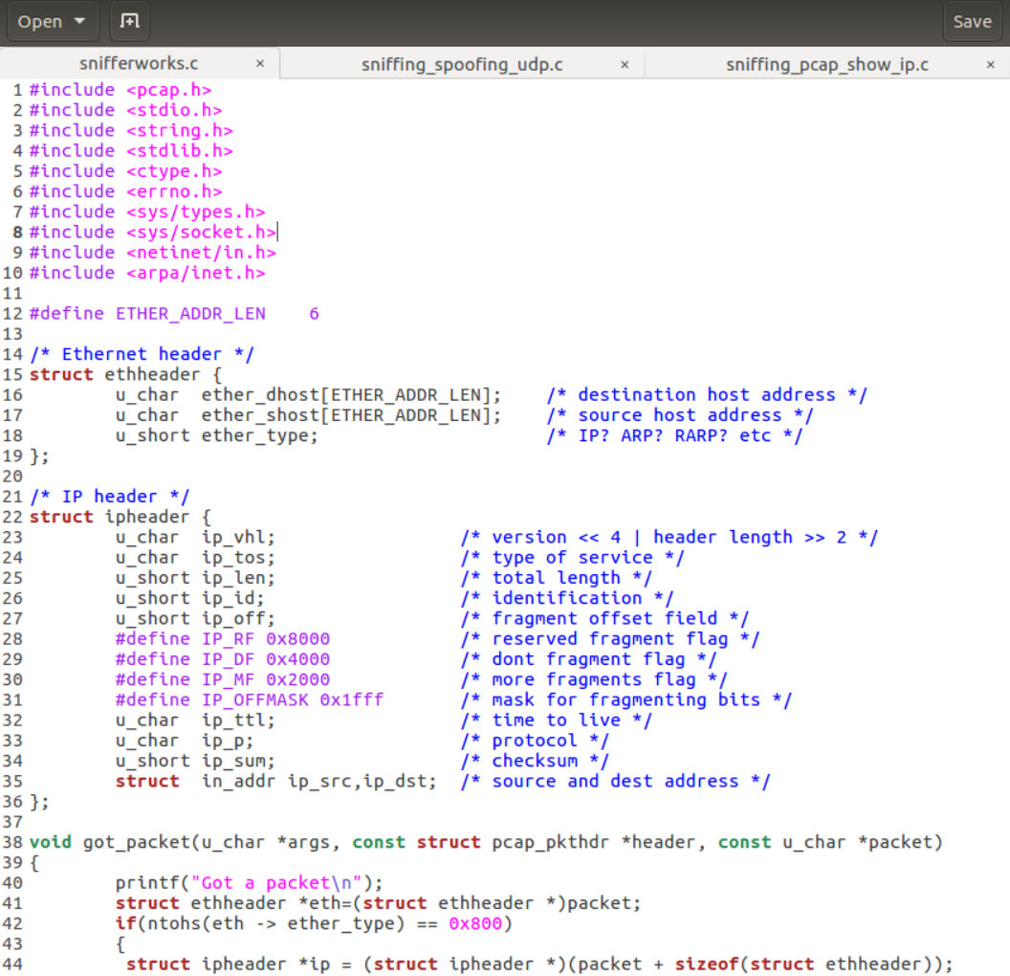

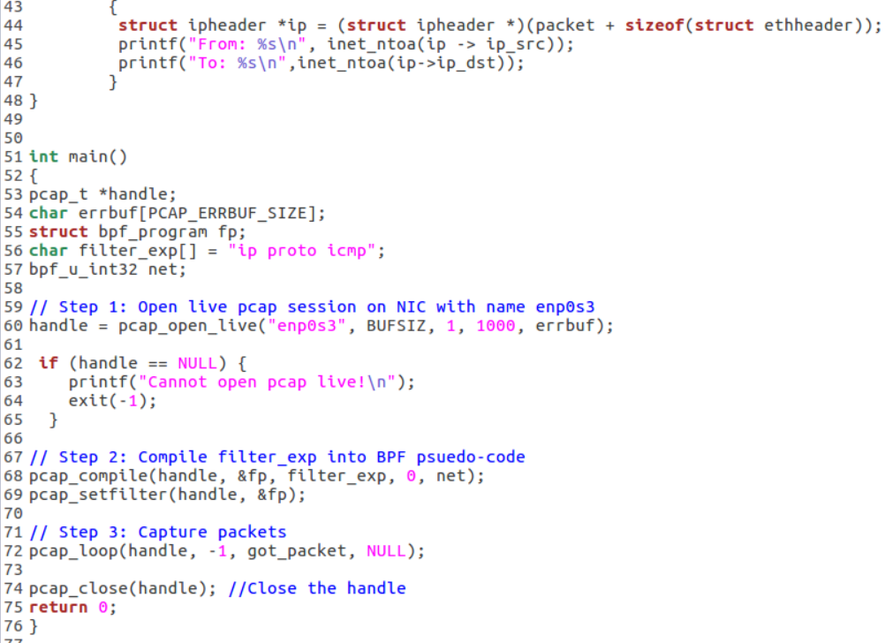

**Figure 16**

* **Q1. Sequence of the library calls that are essential for sniffer program**

The below is the sequence of library calls essential for sniffer program:

**1.Setting up the device**:

The user can specify the device name directly as an argument or in other scenario, pcap setups the device on its own using “pcap_lookupdev()”.The first argument to the function “pcap_open_live” is the device. In this case, the device is “enp0s3” which is the name of the ethernet on the VM that is running.

**2.Opening the device for sniffing:**

“pcap_open_live”opens a session on network interface to perform sniffing once the device has been defined. Sessions are independent , there can be multiple sessions on a single device as well.

**3.Filtering traffic:**

“pcap_compile” ; “pcap_setfilter”define the conditions of the sniffing duration, type of packets to be captured and other rules.

**4.Actual sniffing:**

There are two techniques to capture packets. We can either capture a single packet at a time(“pcap_next”), or we can enter a loop (“pcap_loop”) that waits for n number of packets to be sniffed before being done.

**5.Close the sniffing session:**

pcap_close() closes the sniffing session

* **Q2.** **Why do you need the root privilege to run a sniffer program? Where does the program fail if it is executed without the root privilege?**

**A.** Below screenshot shows that if the sniffer program is run without root privilege, it fails and displays a message “Cannot open pcap live” because of the code snippet below. Otherwise, it will result in “Segmentation fault”

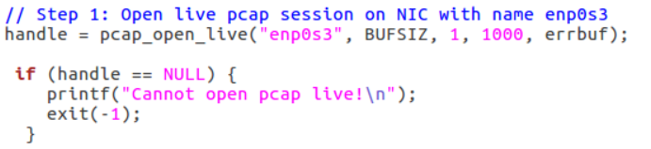

**Figure 17**

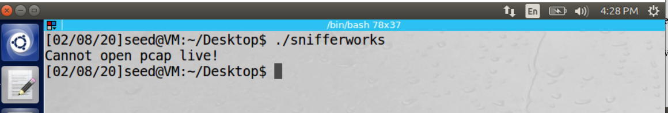

**Figure 18**

**Observation:** Without root access in Linux, it is not possible to open pcap session in network interfaces. It needs to sniff raw packets which needs root permission

* **Q3.** **Please turn on and turn off the promiscuous mode in your sniffer program. Can you demonstrate the difference when this mode is on and off? Please describe how you can demonstrate this.**

**A.** Promiscuous mode enables us to receive packets which are not intended to us but pass through the network. In the below line, the third parameter to “pcap_open_live“ function determines if the promiscuous mode is on or off. If the bit is “1”, the promiscuous mode is on and if it is set to zero, it is off.

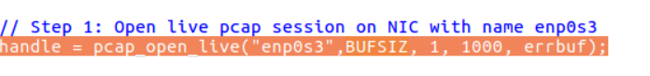

**Figure 19**

Now, setting the promiscuous mode to 0:

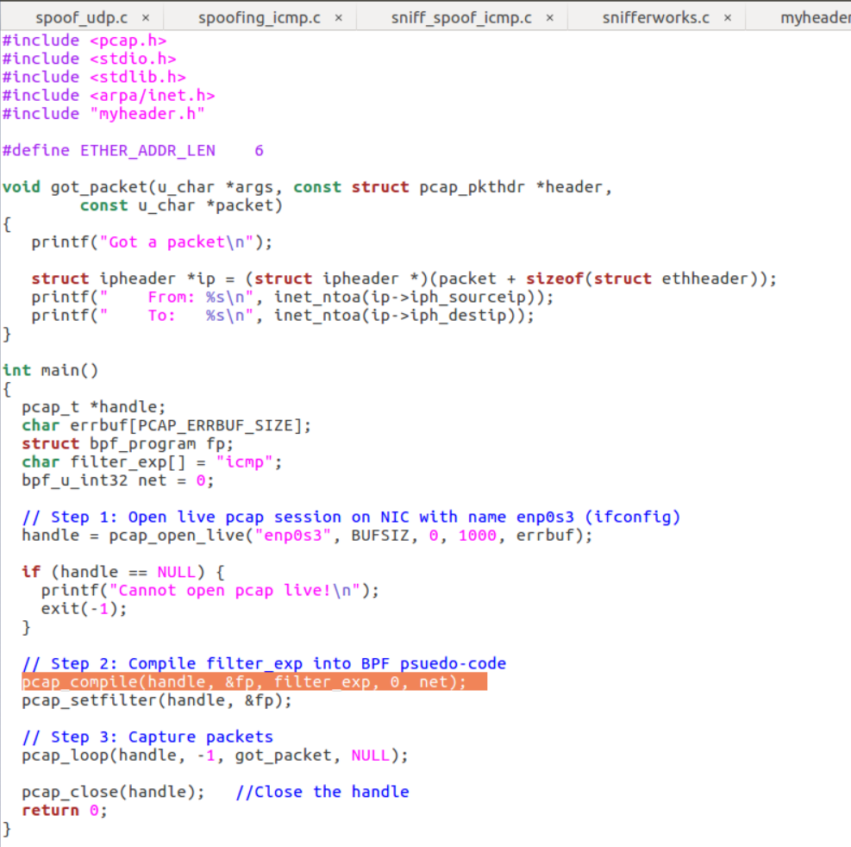

**Figure 20**

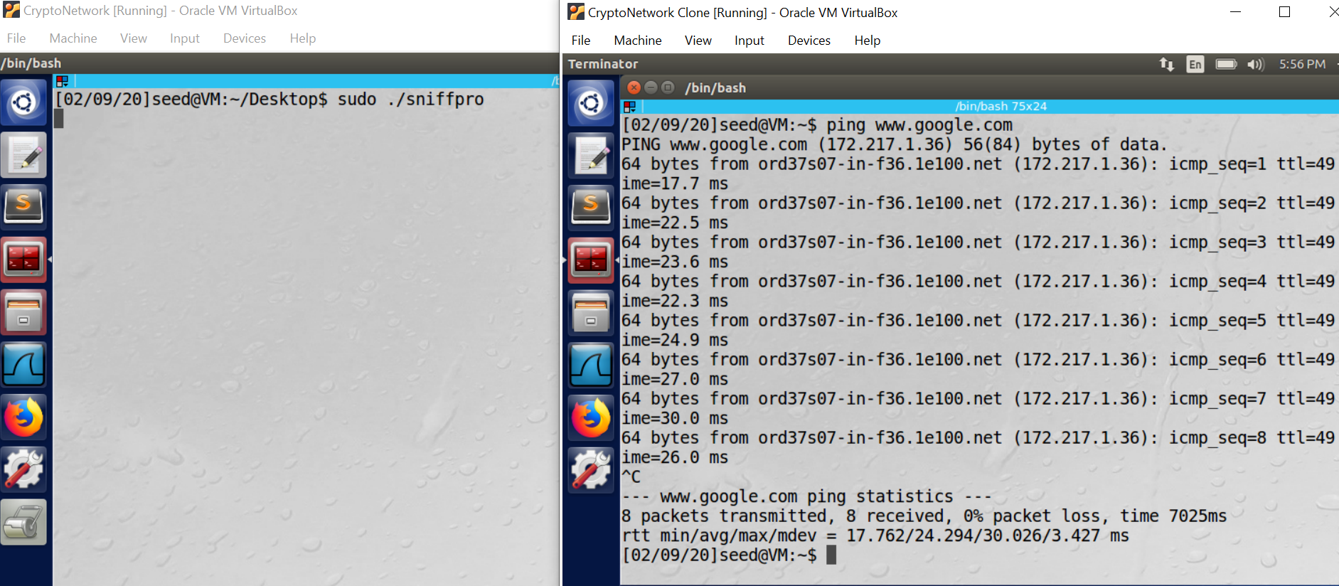

**Figure 21**

**Observation:** When promiscuous mode is off, the code cannot sniff any packets which are not sent to it’s IP. The same is demonstrated in the above screenshots.

**Task 2.1B: Writing Filters**

**• Capture the ICMP packets between two speciﬁc hosts.**

**A.** The highlighted part in the code snippet is used to filter only the ICMP packets between hosts 10.0.2.4 and 10.0.2.6 which are my VM’s:

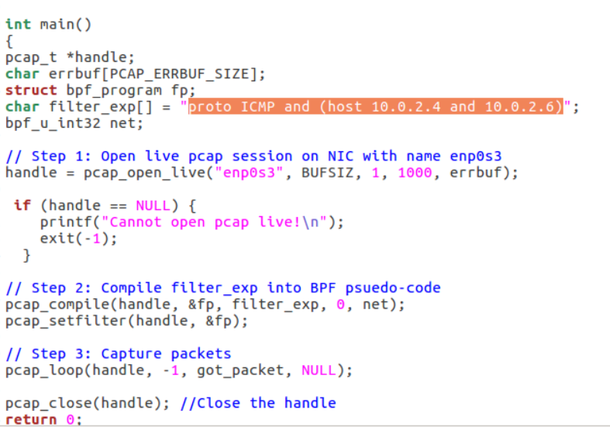

**Figure 22**

Below screenshot shows that I received only ICMP packets because of the filter ICMP in pcap compiler

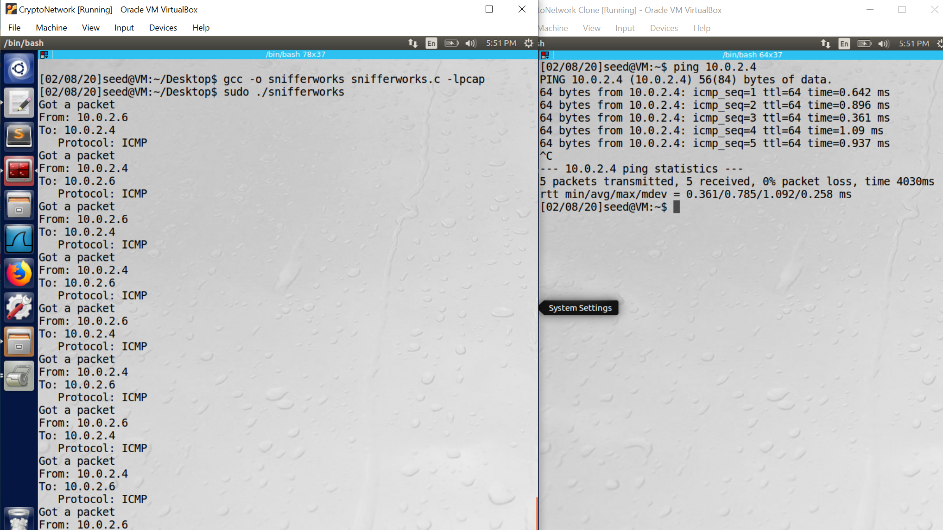

**Figure 23**

**• Capture the TCP packets with a destination port number in the range from 10 to 100.**

**A.** The highlighted part in the code snippet is used to filter only the TCP packets to ports 10-100

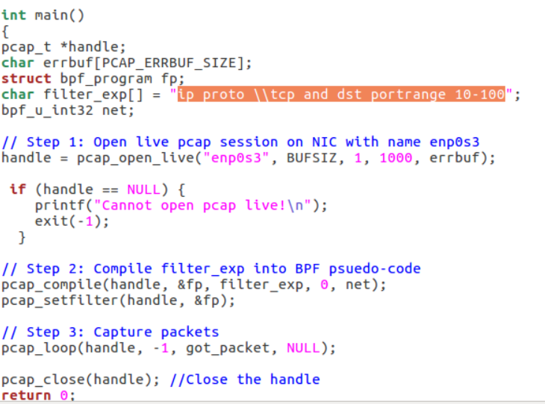

**Figure 24**

**Observation:** Below screenshot shows the two VM’s, one of them running the sniffer code and the other is sending TCP packets. The VM captured only TCP packets because of the filter used.

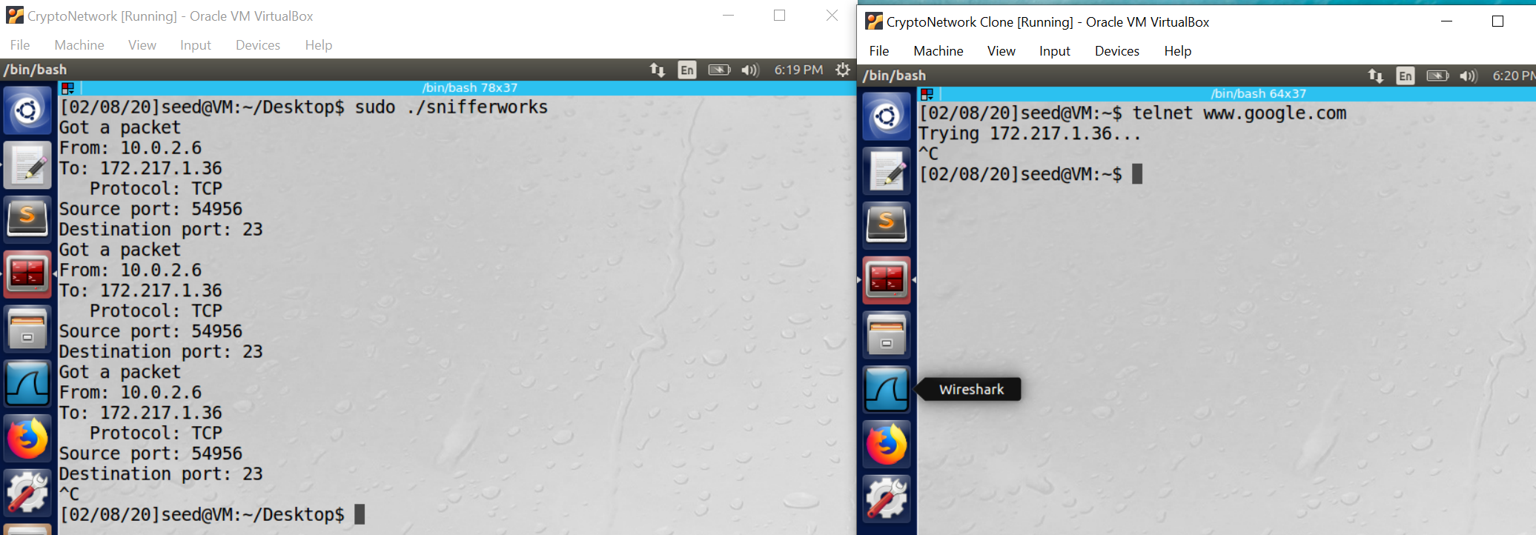 **Figure 25**

**Task 2.1C: Sniffing Passwords**

**A.** The highlighted characters in the below screenshot “dees” is the captured password.

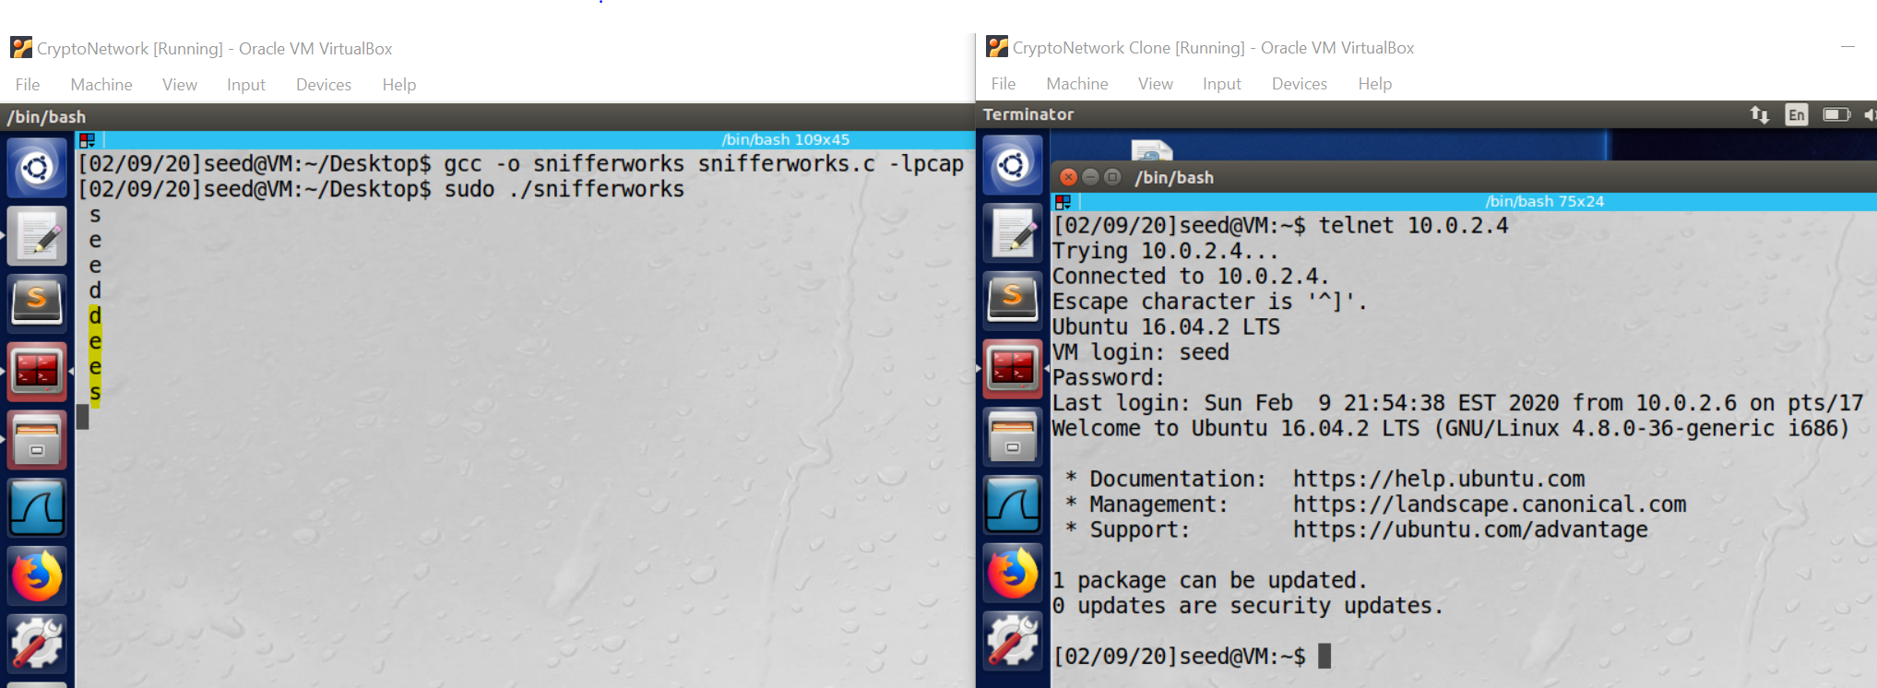



**Figure 26**

**Observation:** In the above screenshot (figure 26), the VM on the left is the attacker running the sniffing program and the VM on the right is the user /victim.

Step1: The user tries to establish a telnet connection to 10.0.2.4 which is the IP of the attacker machine.

Step2: The credentials entered by the user are printed in plaintext in the attacker machine because it is sniffing the entire traffic to the port 23 which includes the username and password.

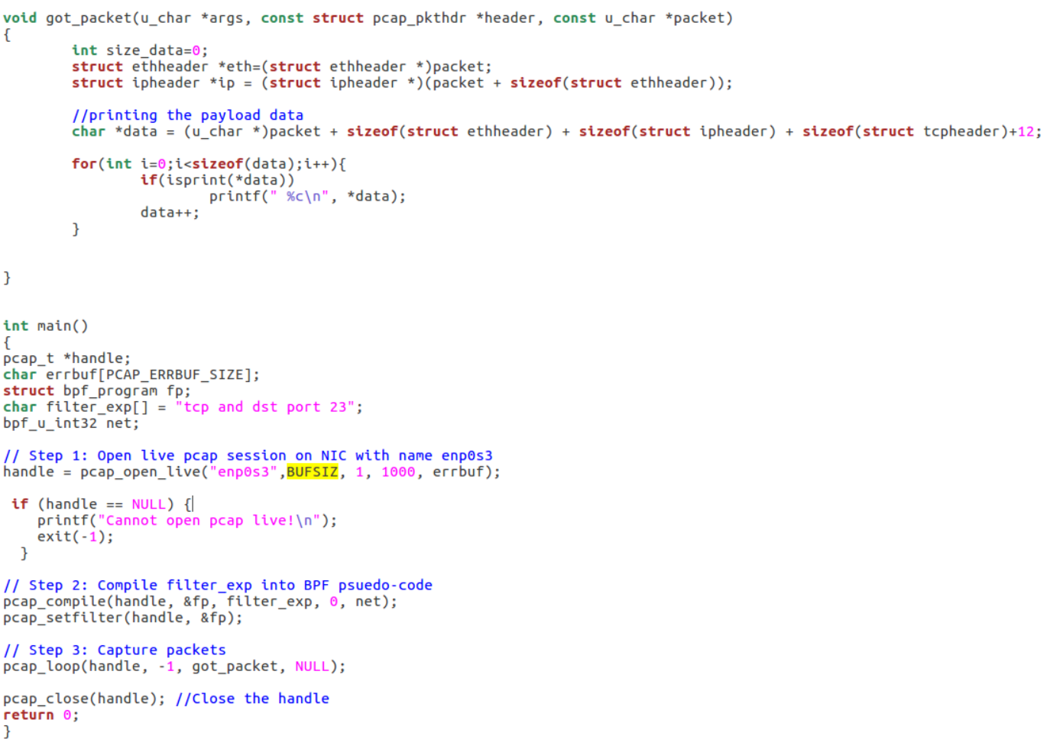



**Figure 27**

**Task 2.2: Spoofing**

**Task 2.2A: Write a spoofing program**

**A.** 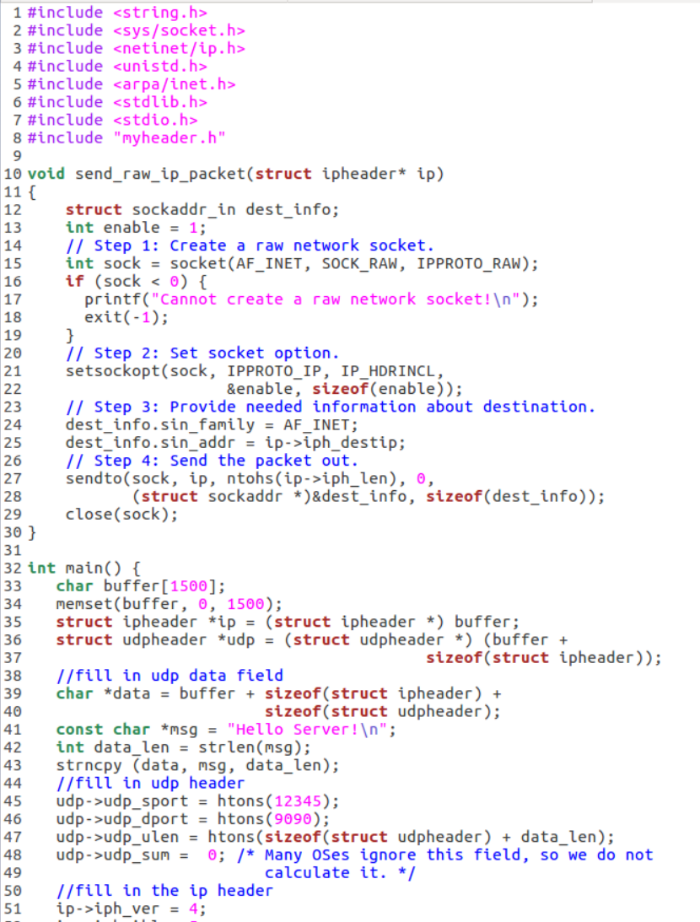 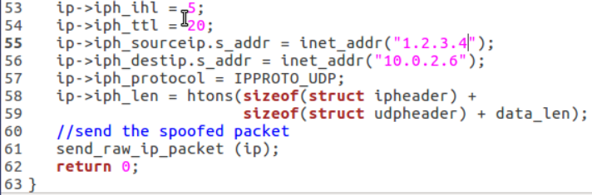

**Figure 28**

The above screenshot shows the code for spoofing UDP packets.

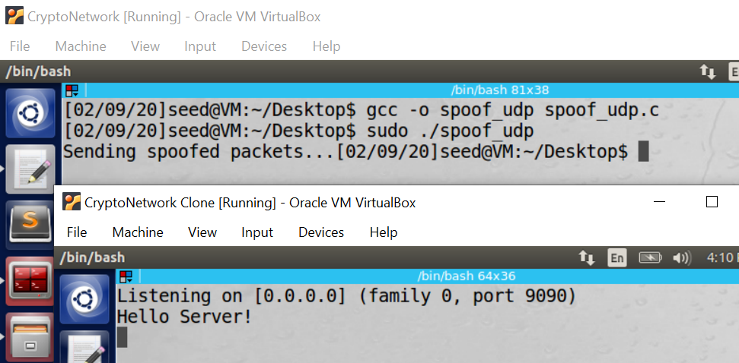

**Figure 29**

**Wireshark capture:**

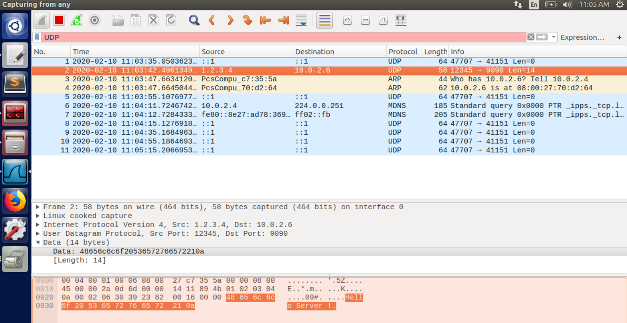

**Figure 30**

The attacker sends spoofed UDP packets with the message “Hello server” and it is captured on the server which is listening as seen in figure 29.

The attacker’s IP is “10.0.2.4” and it sends a spoofed packet with message “Hello server” to “10.0.2.6”. As captured on Wireshark, the source IP is “1.2.3.4” which is set by the attacker.

**Task 2.2B: Spoof an ICMP Echo Request**

**A**

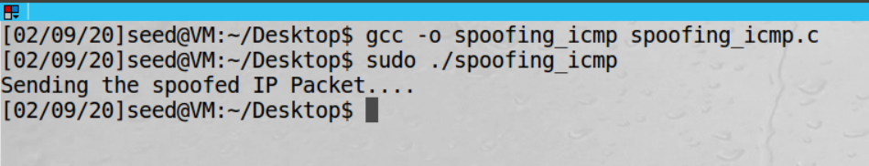

**Figure 31**

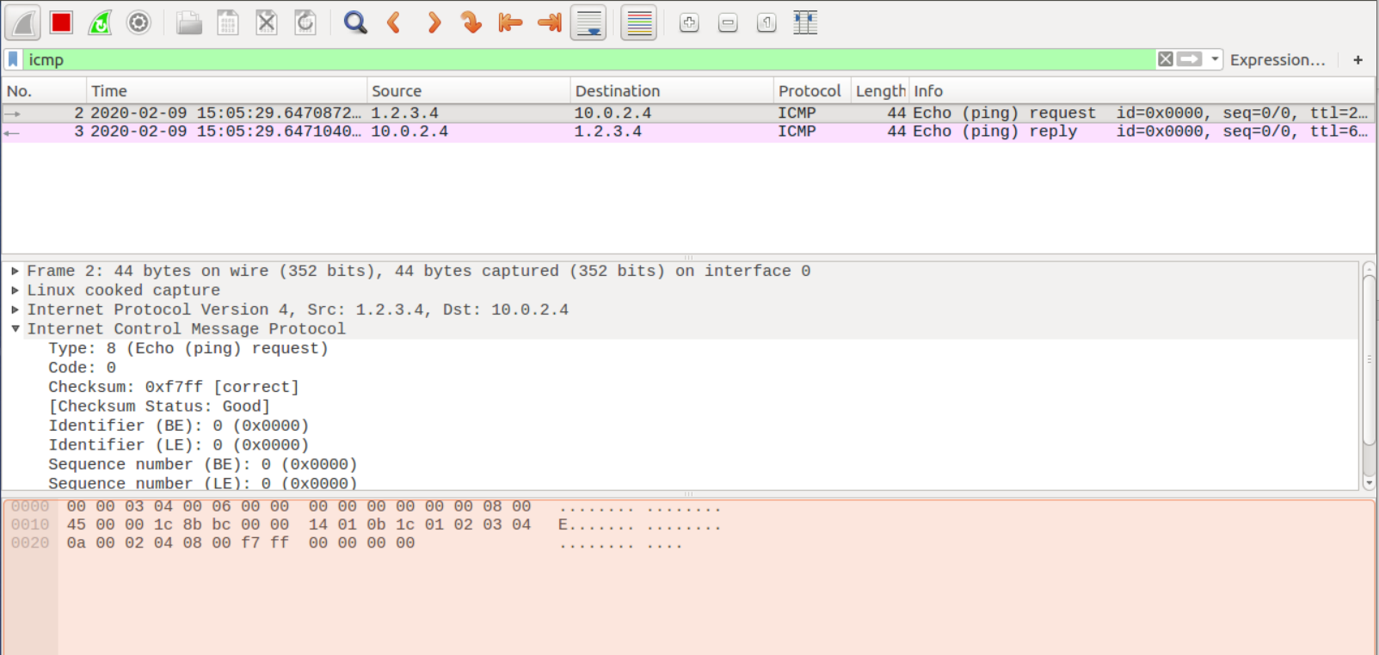

**Figure 32**

**Observation:** In the above wireshark capture, we can observe that the attacker sends a spoofed ICMP packet to the destination “10.0.2.4” and the host sends back the response.

The attacker creates an ICMP packet with source address changed to “1.2.3.4” and then sends a packet to the destination which in turn sends a response.

**.**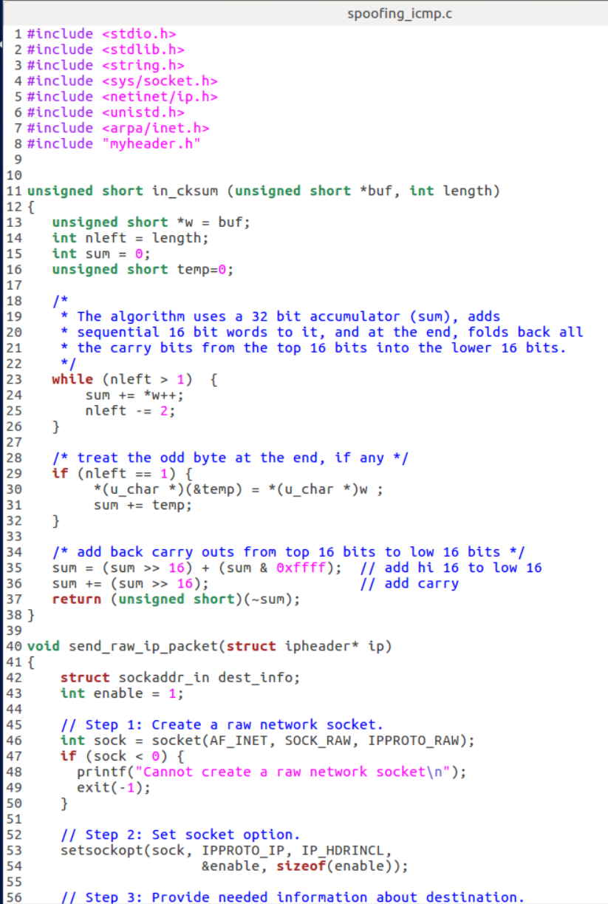

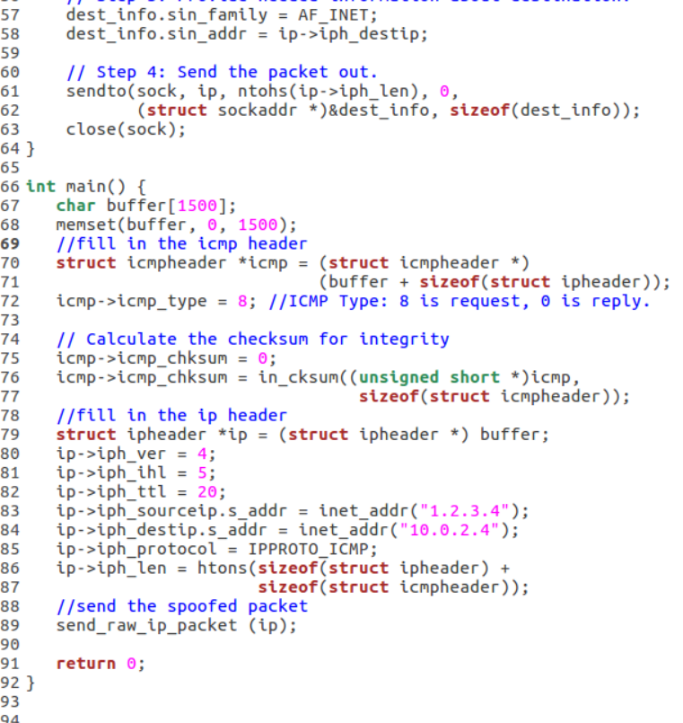

**Figure 33**

* **Q4.** **Can you set the IP packet length ﬁeld to an arbitrary value, regardless of how big the actual packet is?**

**A.** No, the length field must be the length of the IP packet. Otherwise the **sendto** function will send an error.

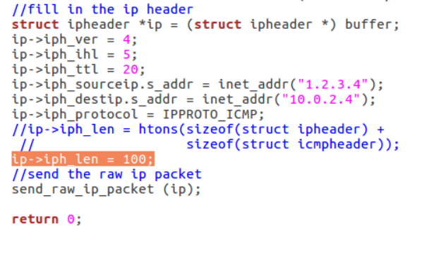

**Figure 34**

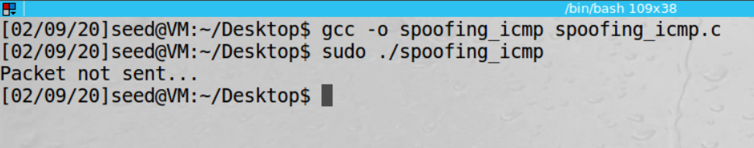

**Figure 35**

**Observation:** The IP packet length field is set to an arbitrary value of 100, the packet is not sent and it is truncated as seen in the above screenshot. The error message is from the code snippet below:

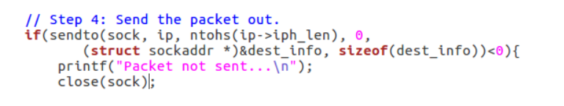

**Figure 36**

* **Q5.** **Using the raw socket programming, do you have to calculate the checksum for the IP header?**

**A.**  No, because the OS calculates the checksum for IP, and we must calculate if we use any other protocol

* **Q6.** **Why do you need the root privilege to run the programs that use raw sockets? Where does the program fail if executed without the root privilege?**

**A.** The networking rules define that we need root privileges to run the raw socket programs because otherwise anyone can fiddle with the packets and that would be detrimental to a network configuration.

**Task 2.3: Sniff and then Spoof**

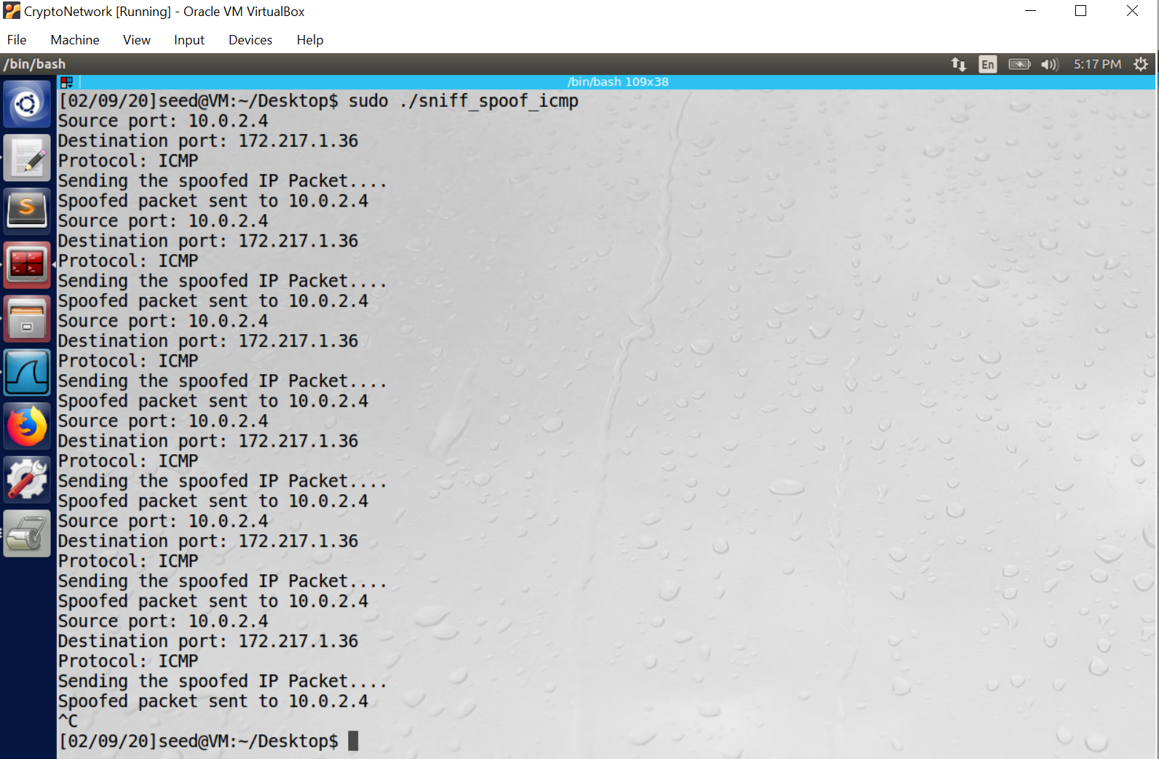

**Figure 37**

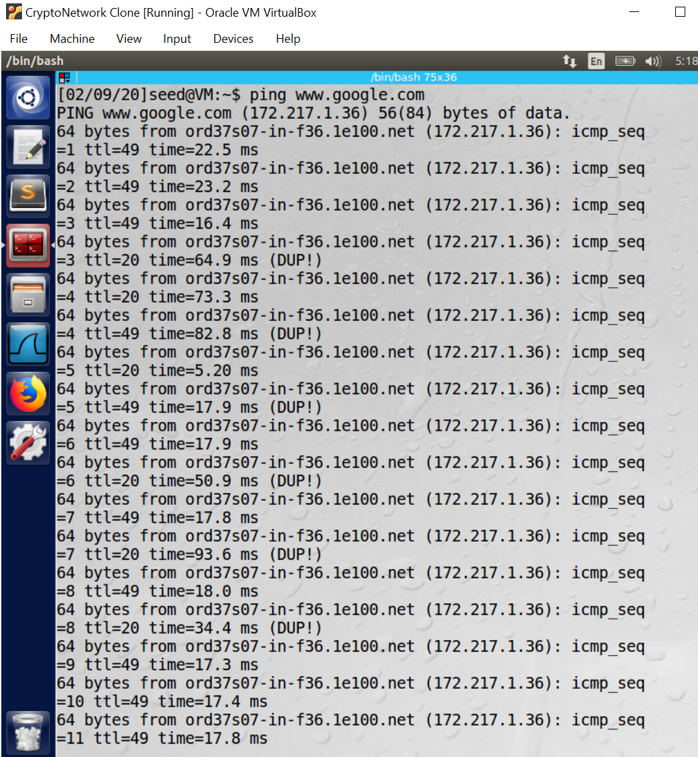

**Figure 38**

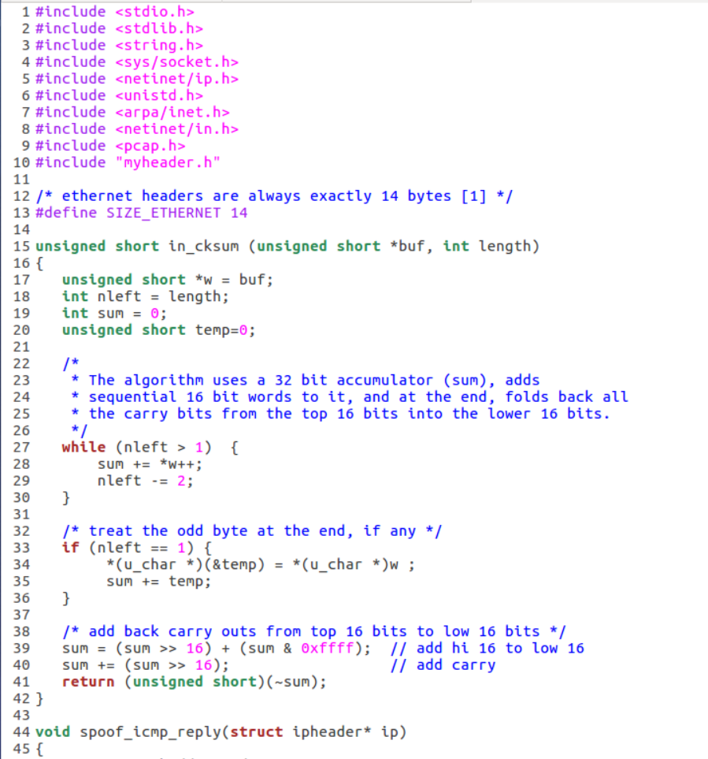

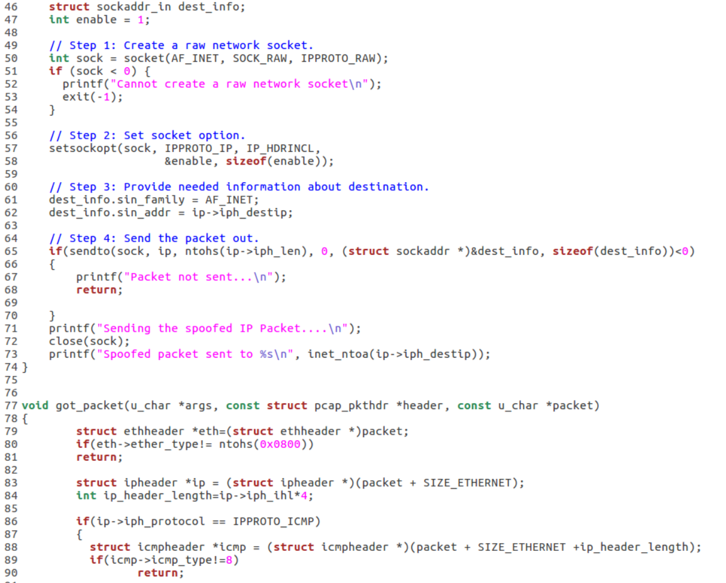

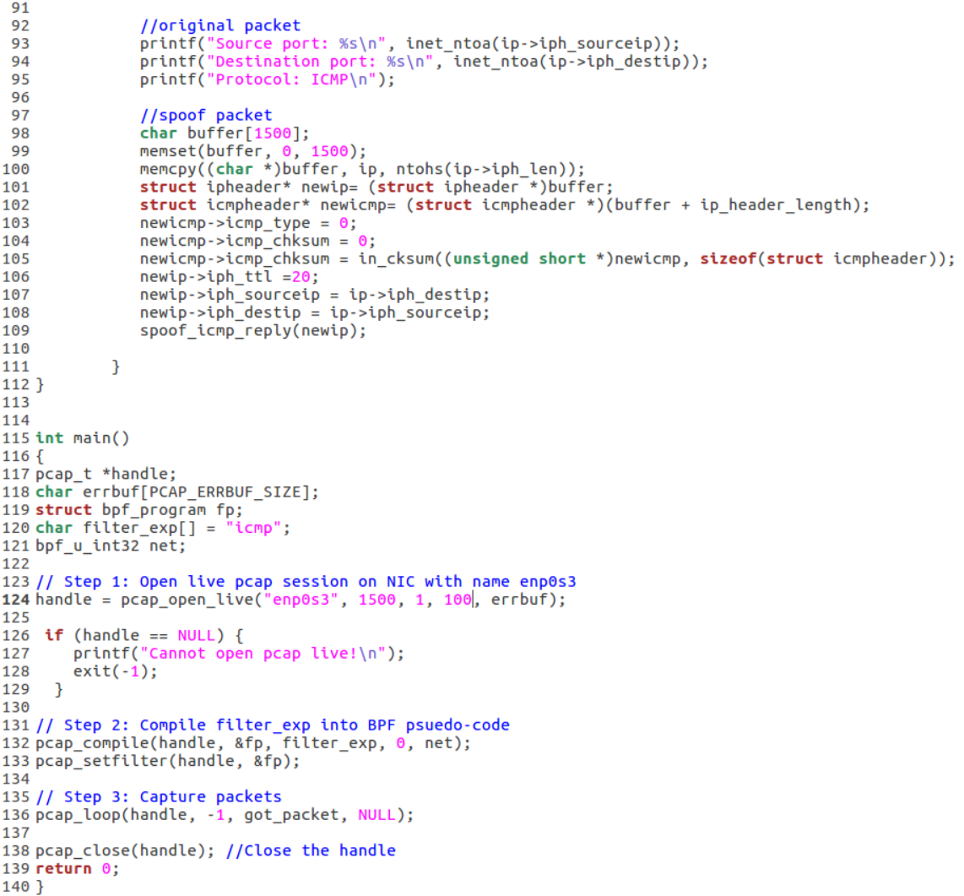

**Figure 39**

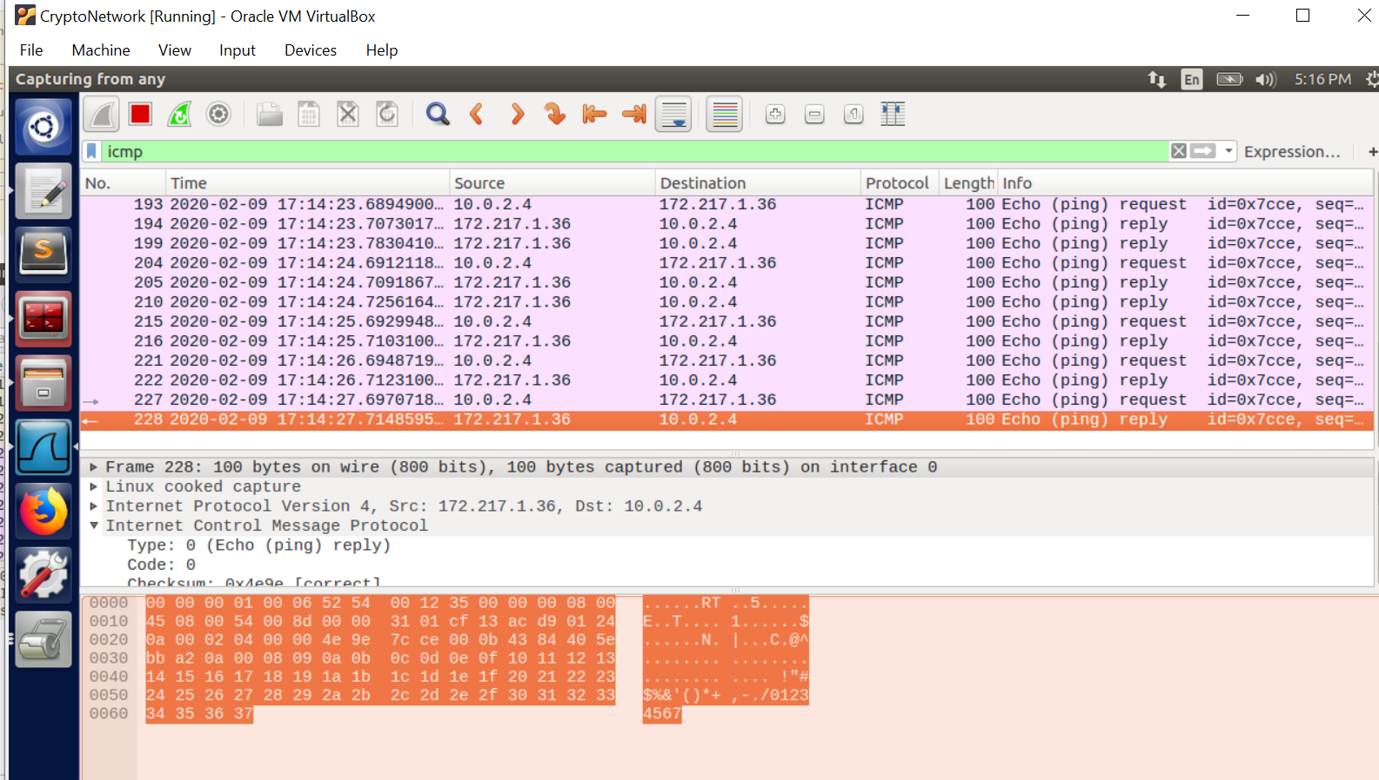

**Figure 40**

**Observation**: User pings google and the attacker sniffs the request and sends a spoofed reply by switching the source IP to destination IP and vice versa , so that it seems like the user received the response from his requested IP.

**Explanation:** The user sends an ICMP echo request to [google.com](http://www.google.com) which is “172.217.1.36”. The attacker sniffs this packet using pcapwhich is listening to the traffic (promiscuous mode on), and then sends a spoofed response back to the user by changing the source IP to destination IP and vice versa as seen in the code ( line107 , figure 39).